**Limit Bit Redeems Per Person StreamerBot Extension**

**Created by Vengey**

**[** [**https://twitter.com/ItsVengey**](https://twitter.com/ItsVengey) **|** [**https://www.twitch.tv/itsvengey**](https://www.twitch.tv/itsvengey) **|** [**https://vengey.carrd.co/**](https://vengey.carrd.co/) **]**

**How to Import into StreamerBot…**

**STEP 1: *Copy this LONG string***



**STEP 2**: ***Click Import in Streamerbot***

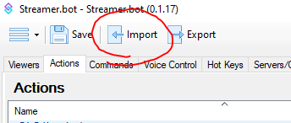

**STEP 3**: ***Paste the code into “Import String”, an action will show up, then hit “Import”***

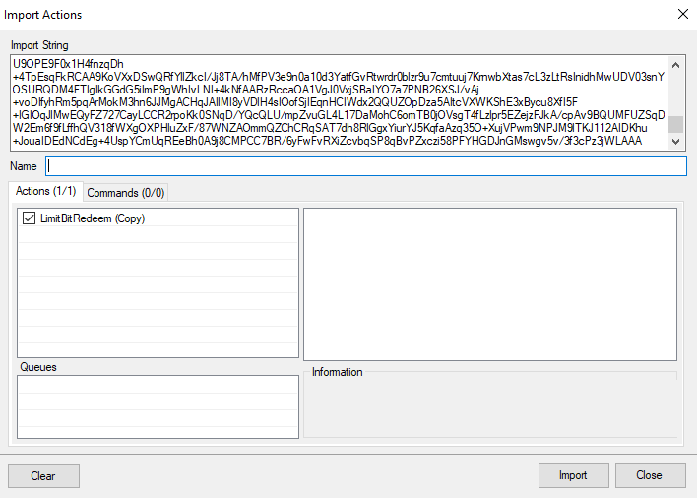

**STEP 4**: ***Go to your Actions tab; look for an action called “LimitBitRedeem”***

Set UserRedeemLimit to however many times you want a user to be able to redeem this

***IF you want just a video to play….***

Set SceneName to the exact name of the scene where your video will play

Set SourceName to the exact name of the source

Set SourceLengthMilliseconds to the duration of the clip in milliseconds

***IF you want your own custom action to run***

Set ActionName to the name of the action you configured

***IF you want a message to be sent to chat when the user has just one redeem left***

Set MessageOneLeft to whatever you’d like (or keep it blank to not send anything)

***IF you want a message to be sent to chat when the user has no redeems left***

Set MessageNoneLeft to whatever you’d like (or keep it blank to not send anything)

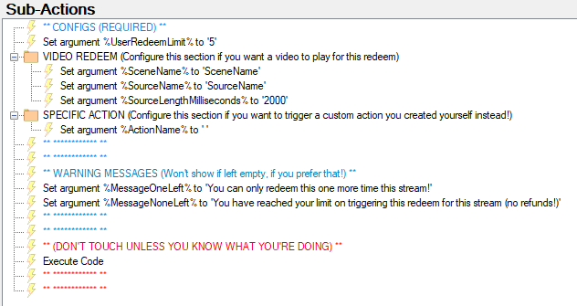

***And that’s it! Wire this action up to a bit/cheer redeem event (platforms > twitch > events > cheers > cheer ranges). Rename the action to whatever you want it to be and just duplicate this action for any future bit cheers you want setup like this, just change the variables to fit your needs!!!!***

***NOTE: This is a possible example of what it could look like when the messages get sent to chat!***

